Fiori Launchpad:

Prerequisites:

* Launchpad service
* Trial balance and Post JE URLs.

Launchpad Service:

* Create launchpad service from service marketplace.

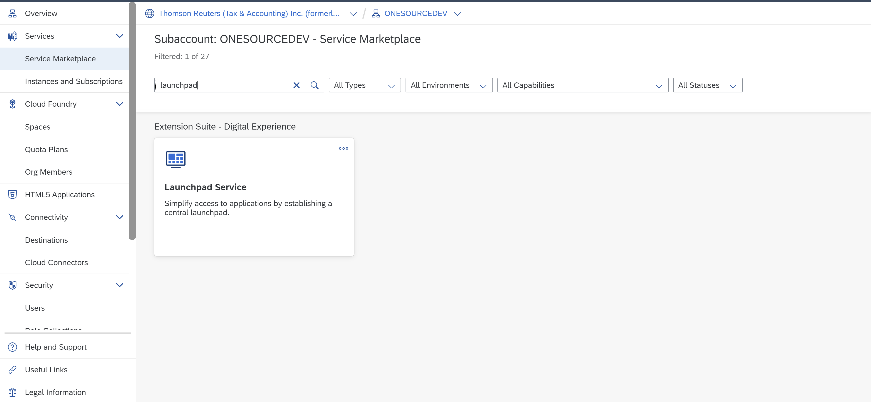

* Click on go to application button

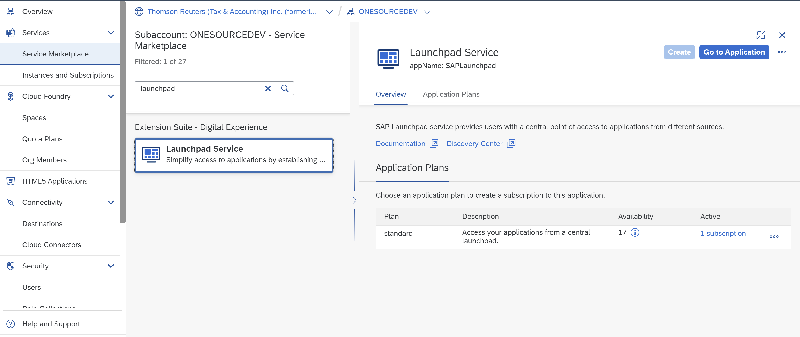

* Below screen (site directory will open) then click on **Create Site**

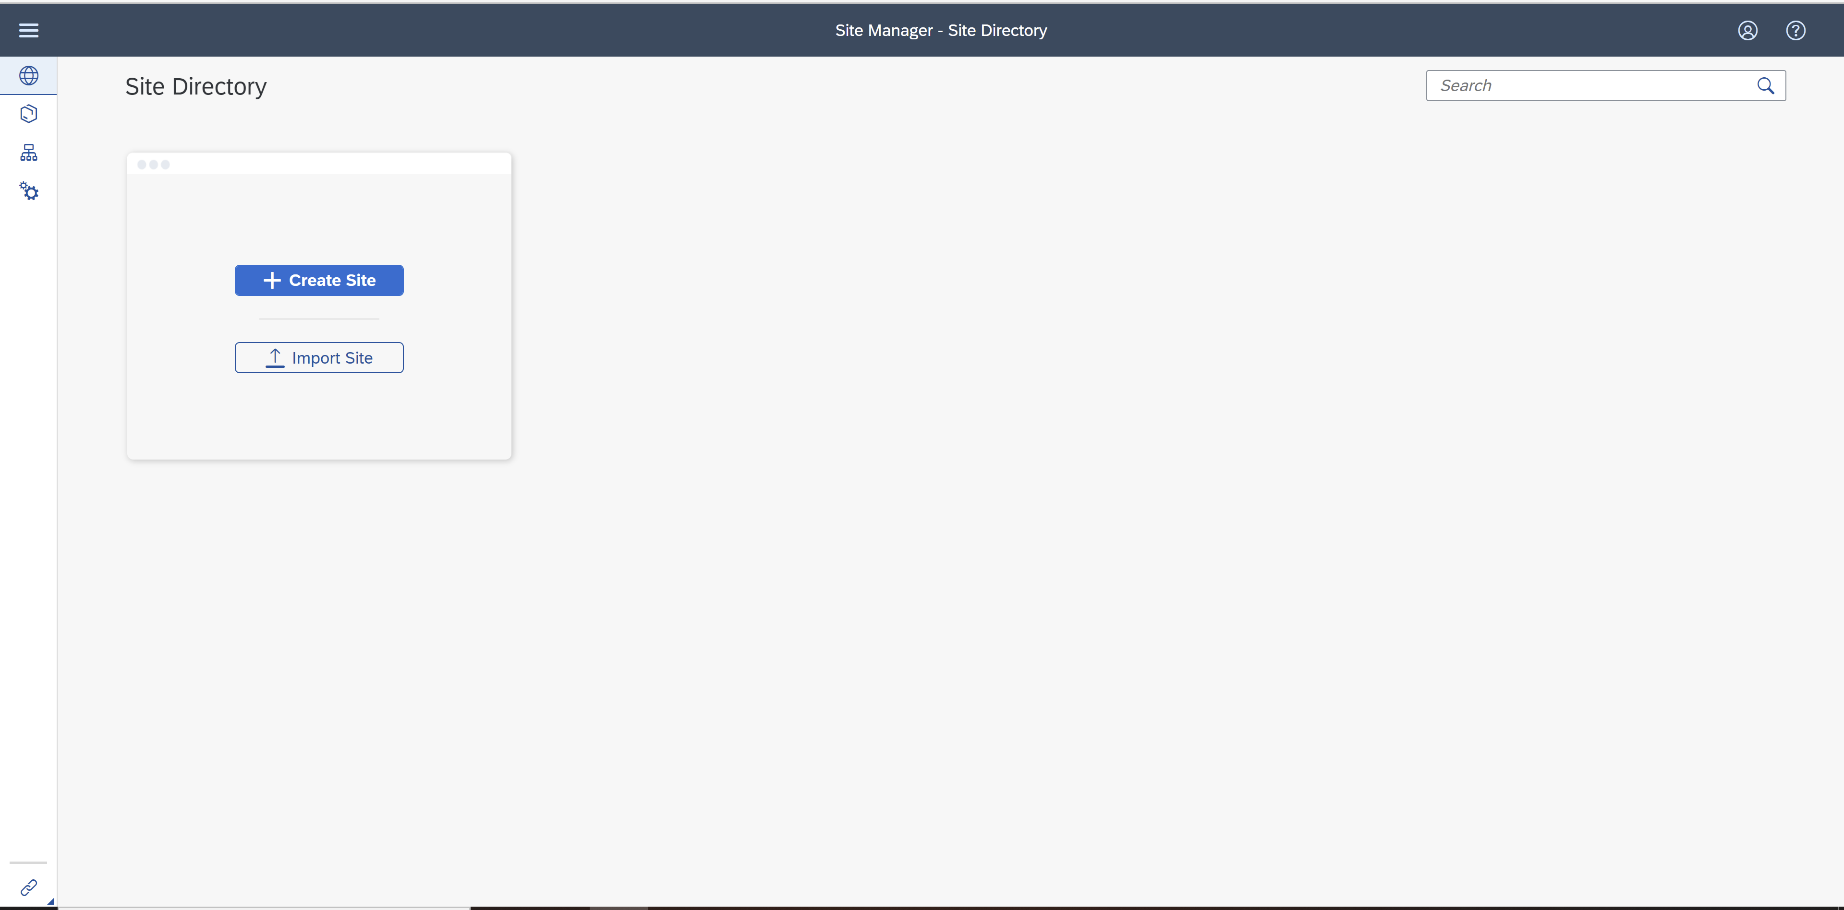

* Go to Content Manager

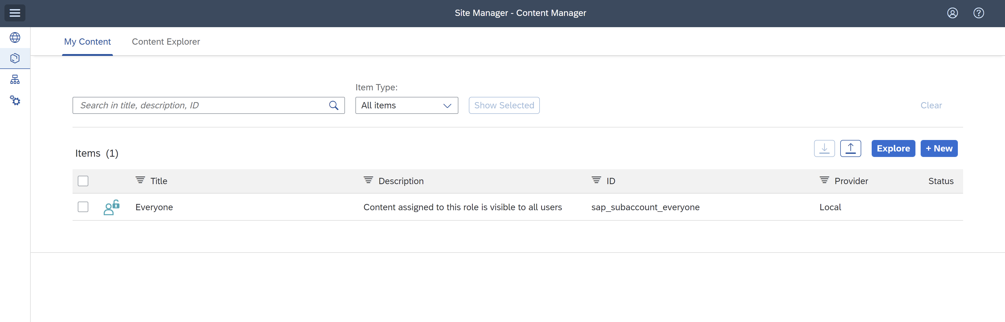

**Create Trial balance App:**

**Tile:** Send Trial Balance to ONESOURCE

**Subtitle:** Select and Send S/4HANA Trial Balance to ONESOURCE

* Give app Title and description.
* Make sure select **Open App in a new tab** radio selected.
* System – No system, App UI technology URL.
* URL – Subscribed app url

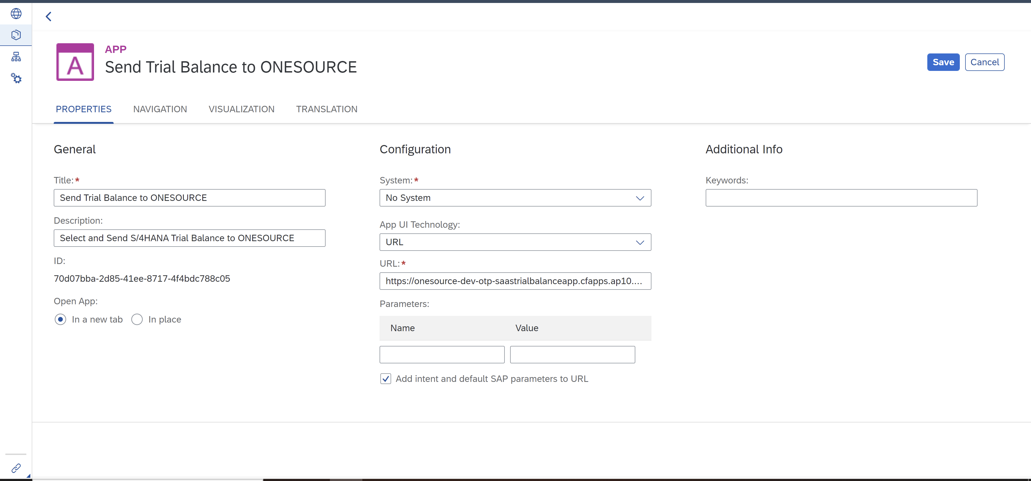

Make sure give correct values for semantic object and Action

* Semantic Object – Trialbalance
* Action – display
* Parameters are not required.

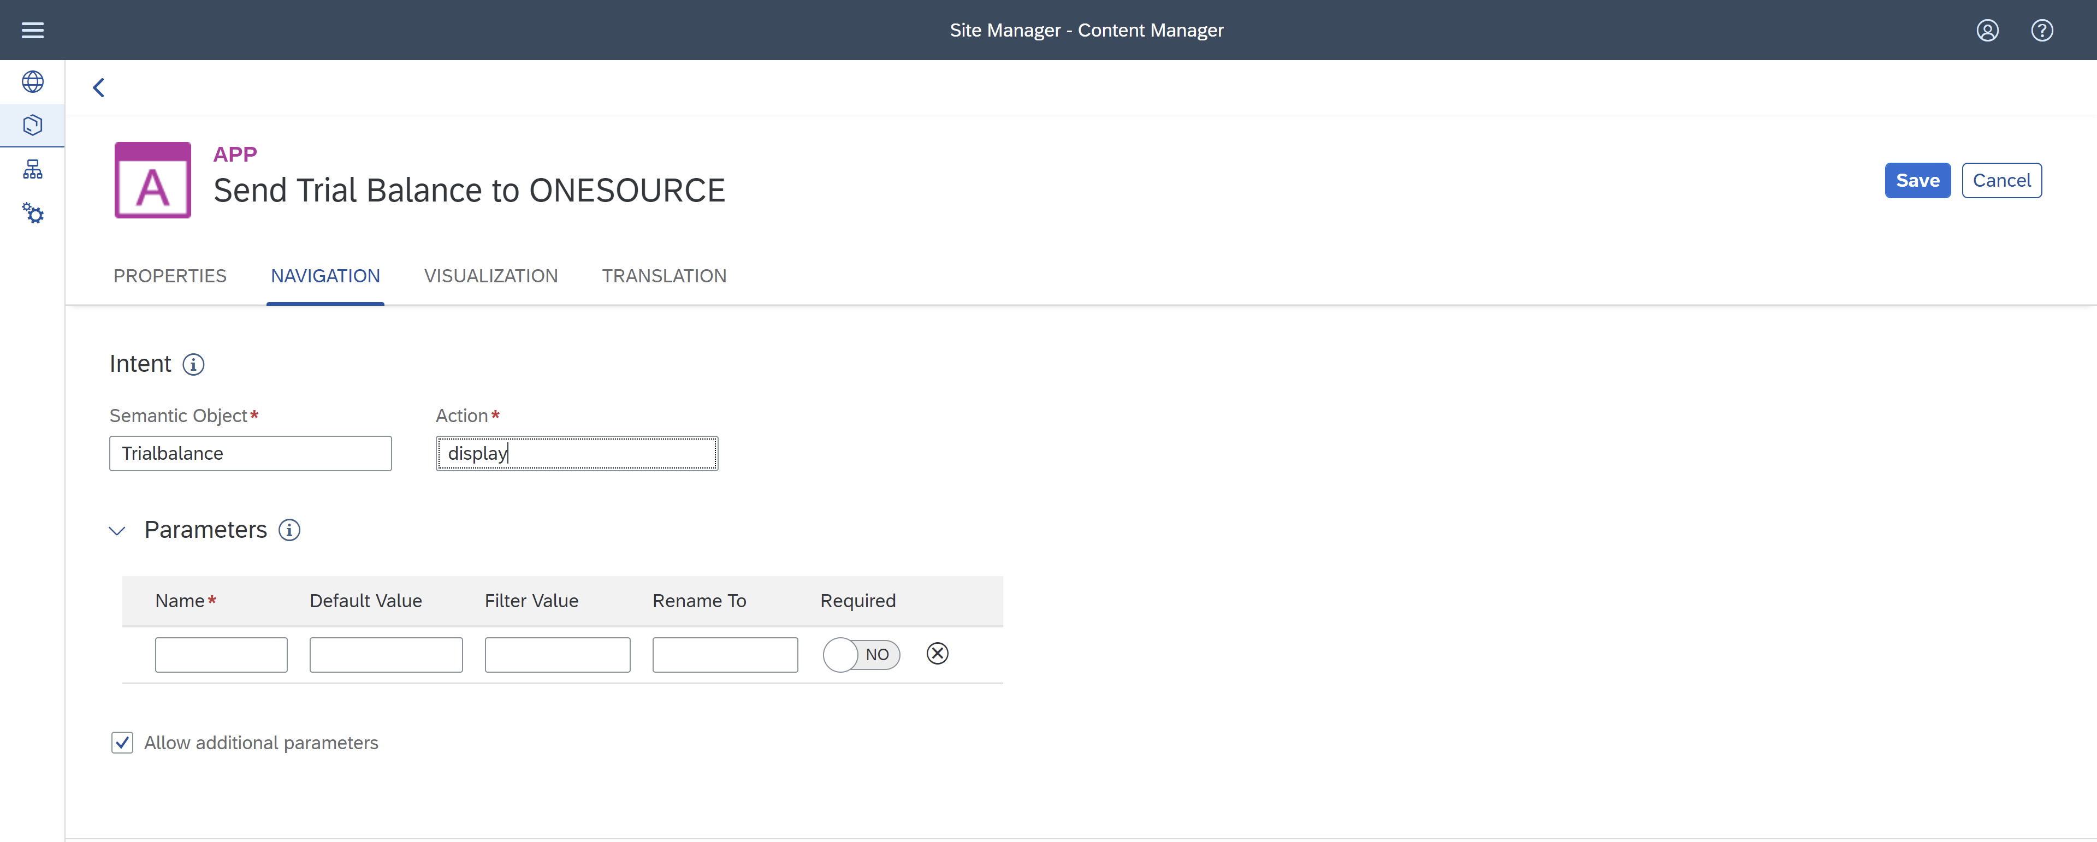

* In Visualization Section give the Tile Properties title, subtitle and Icon.
* Save your app.

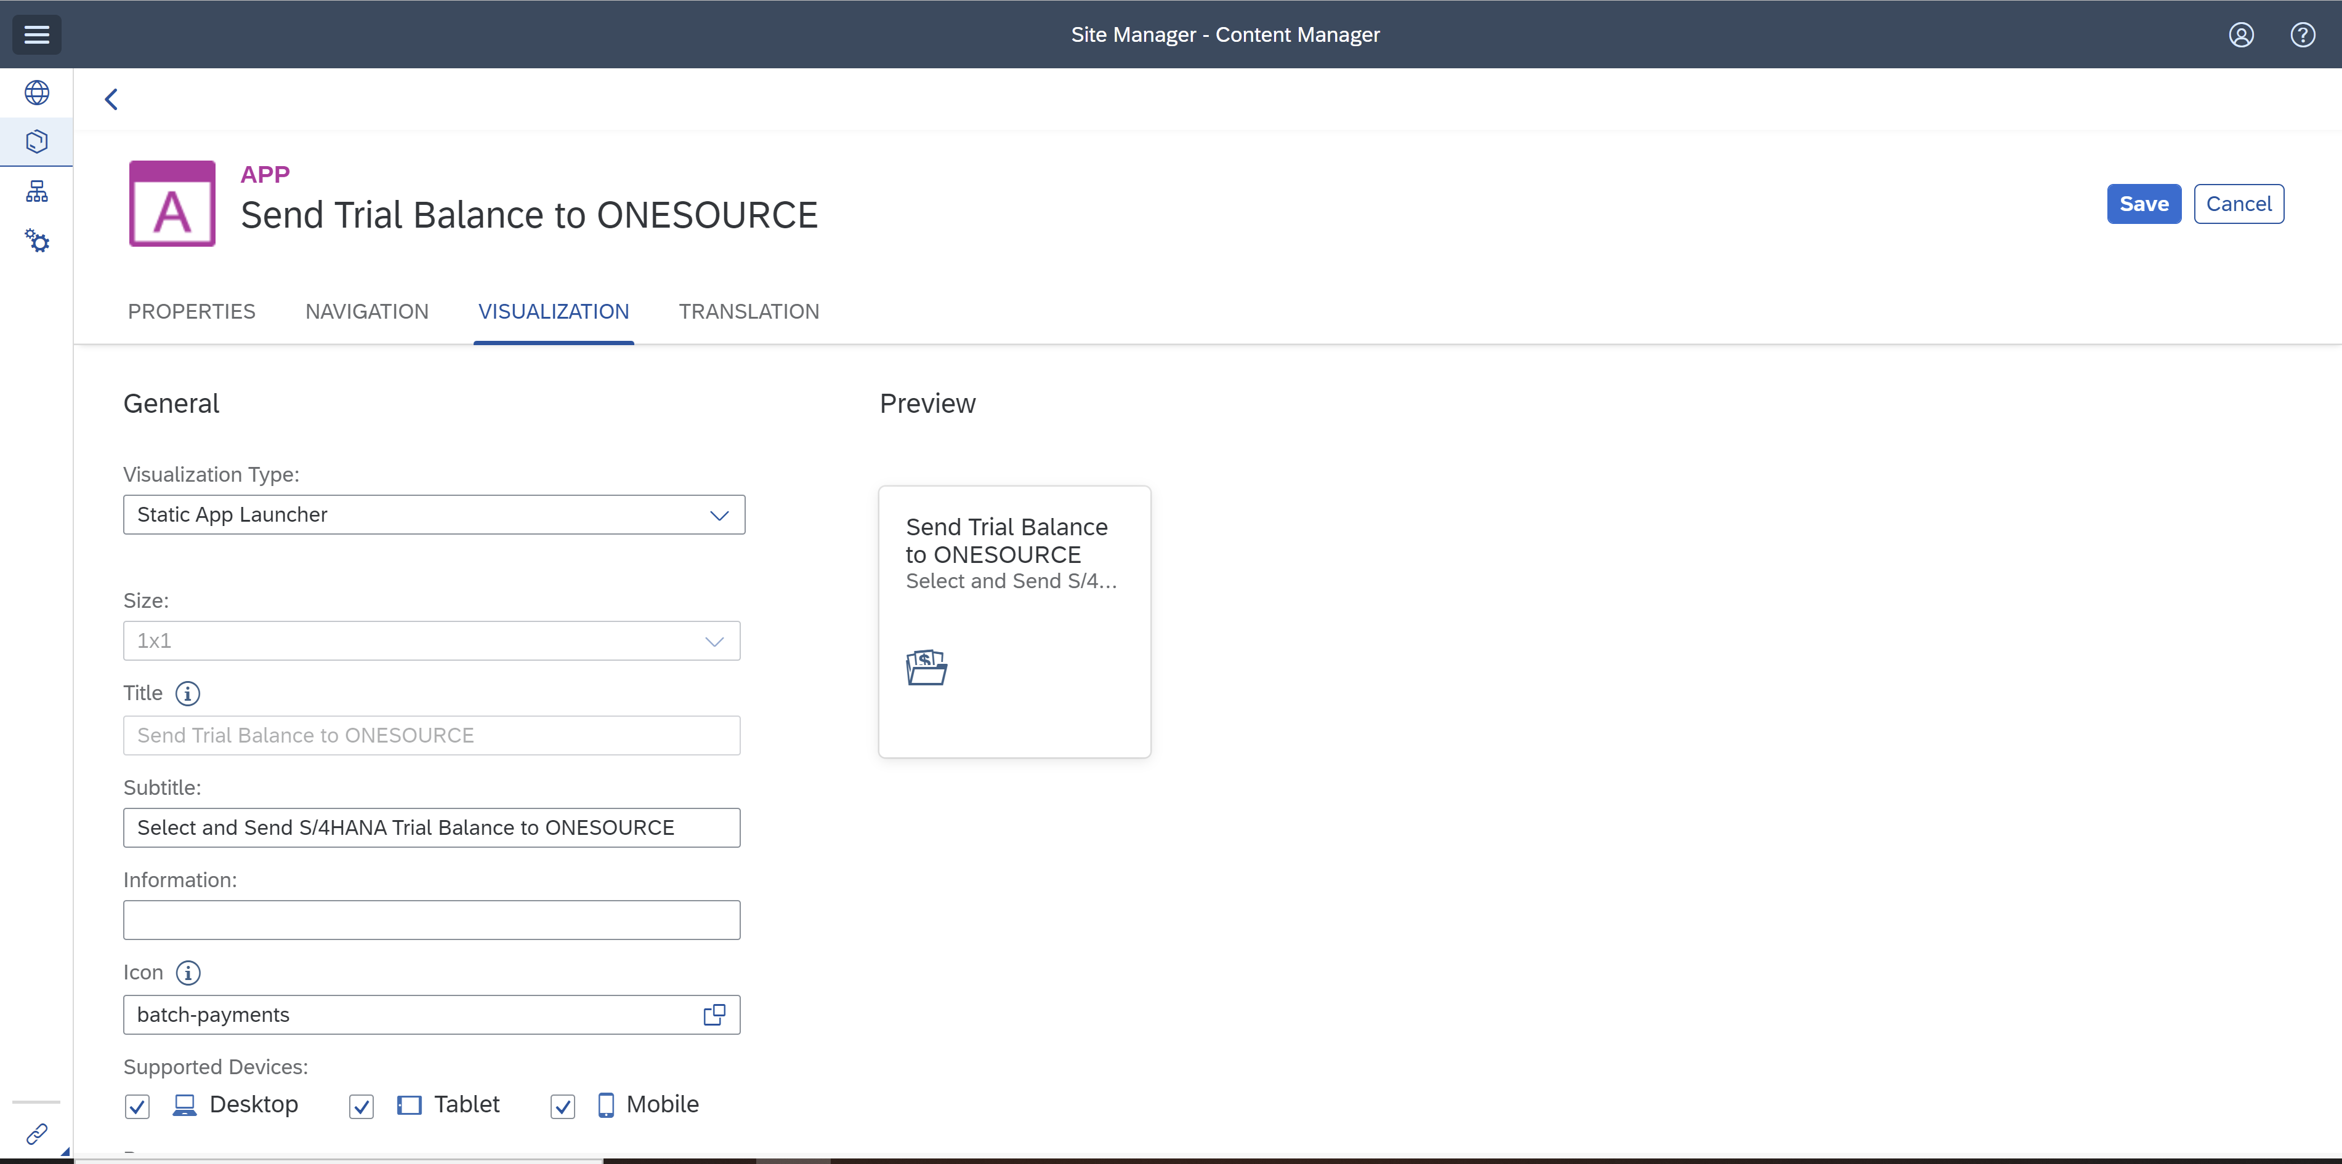

**POST JE APP:**

**Tile:** Post Income Tax Journal Entry

**Subtitle:** Review and Post ONESOURCE Tax Provision Journal Entry to S/4HANA

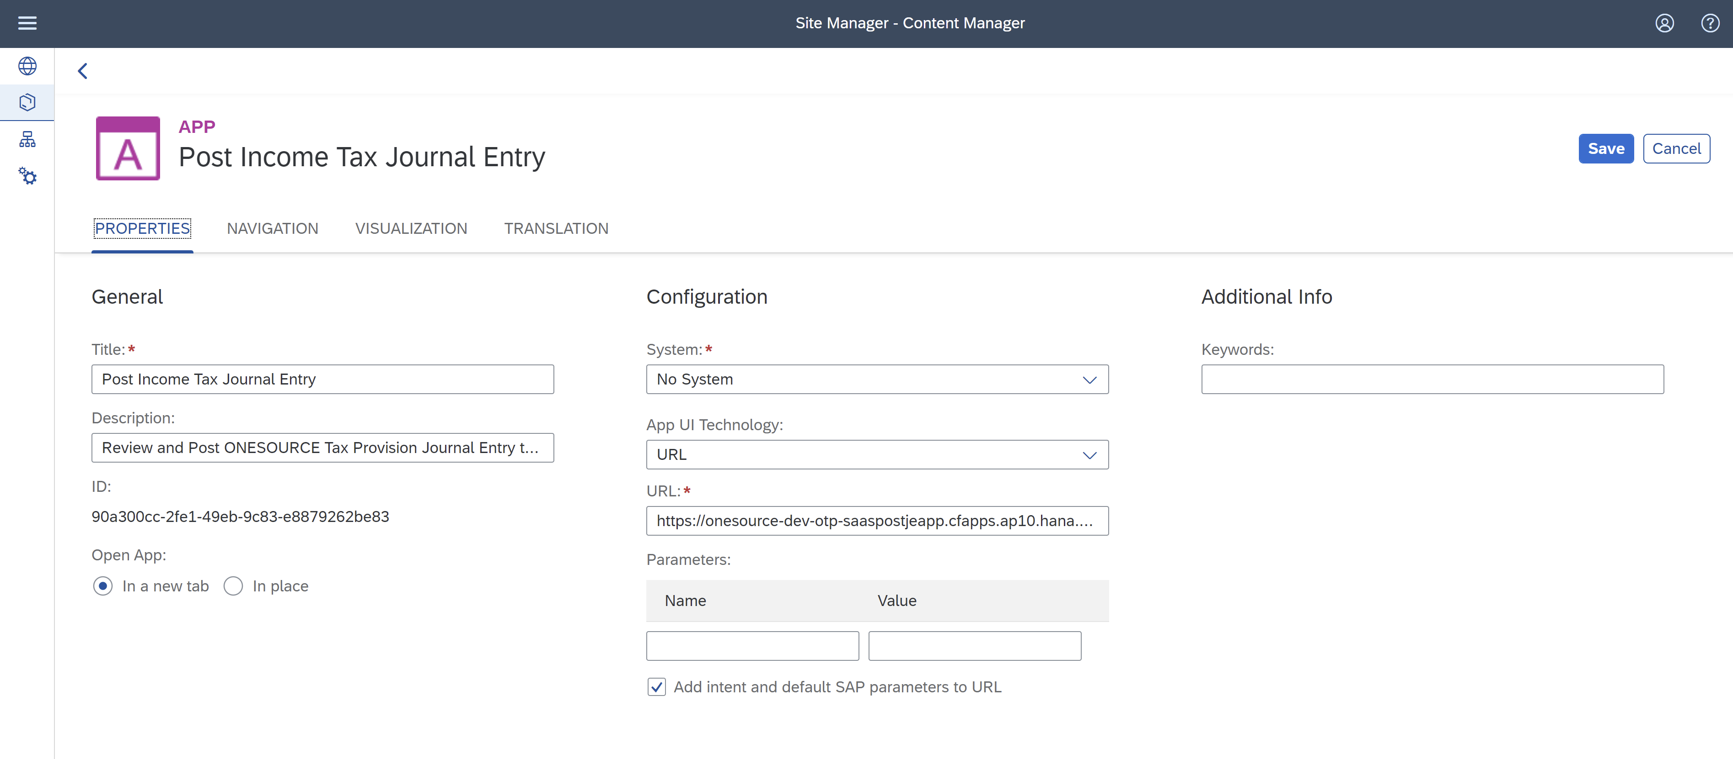

Make Sure give correct semantic object and Action.

* Semantic Object- PostJE
* Action - dispaly

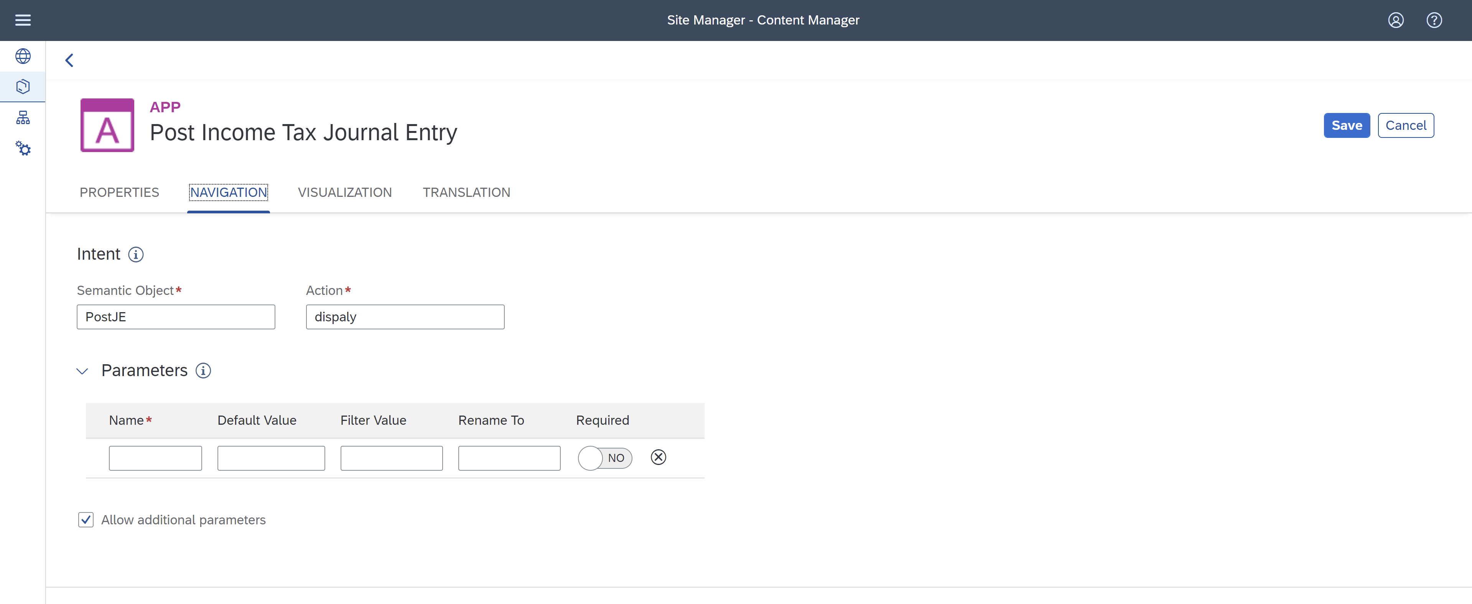

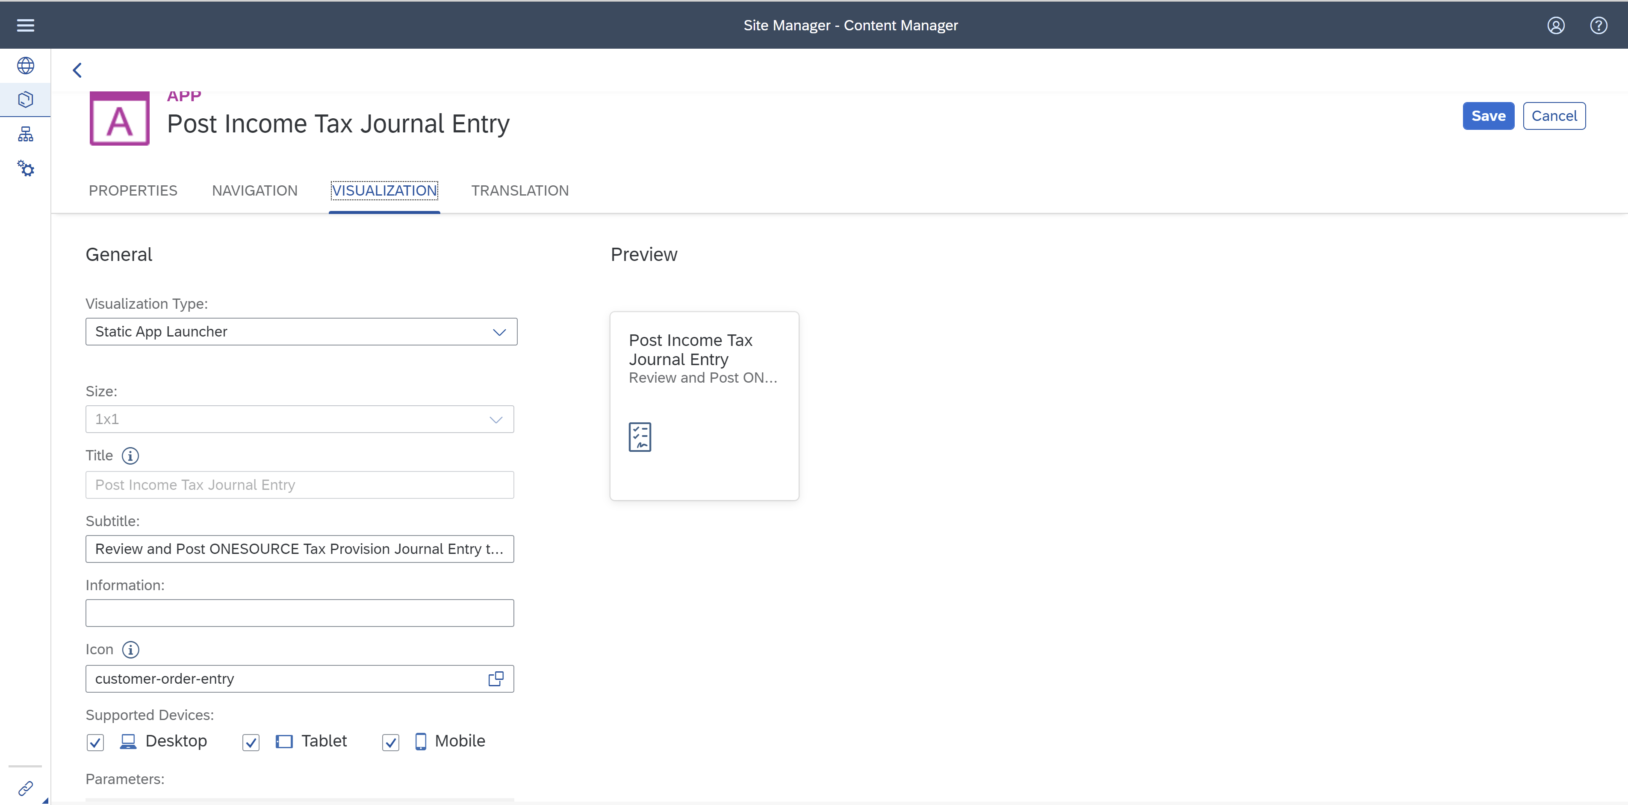

**Create Catalog and Group:**

* Give Title and description.
* Click on the Assign Items search bar then you can see the list of apps.
* To add apps click on + icon.

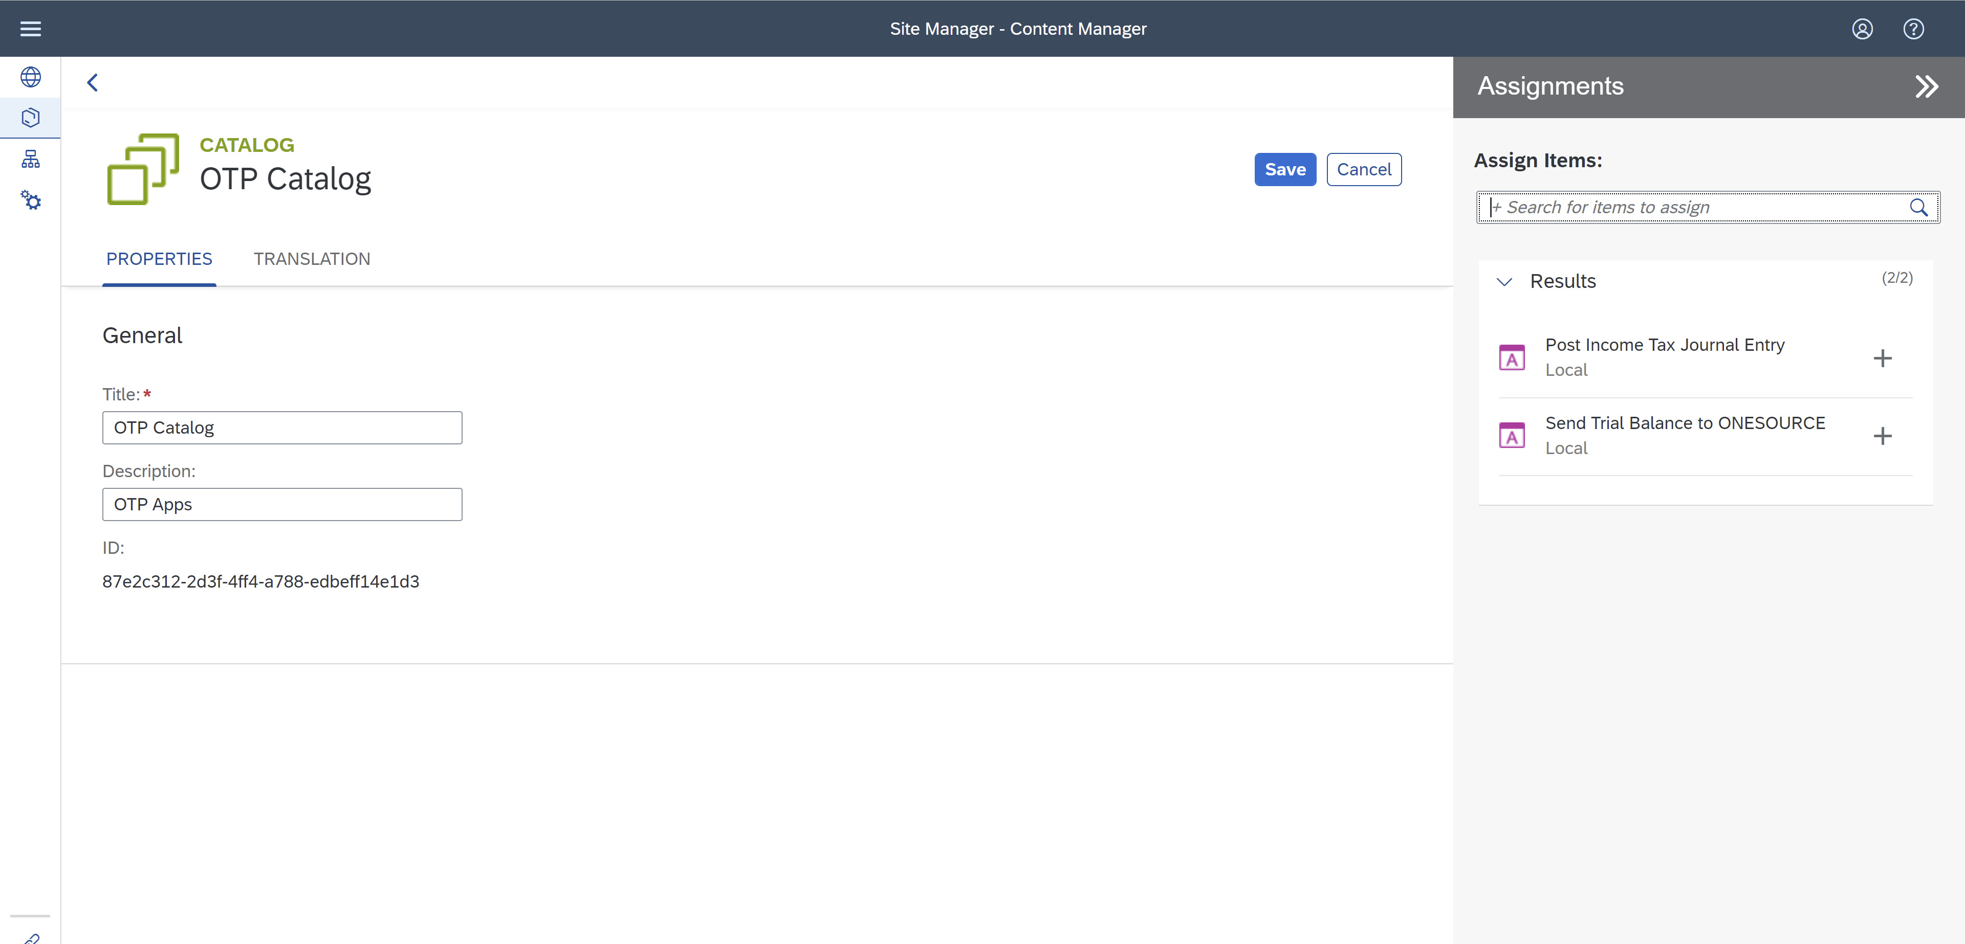

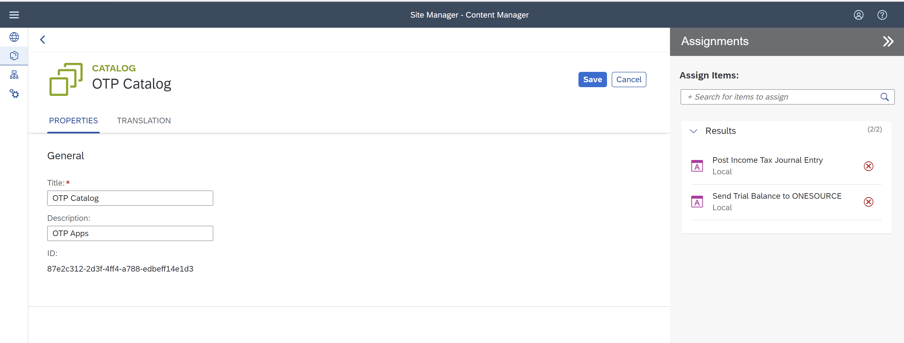

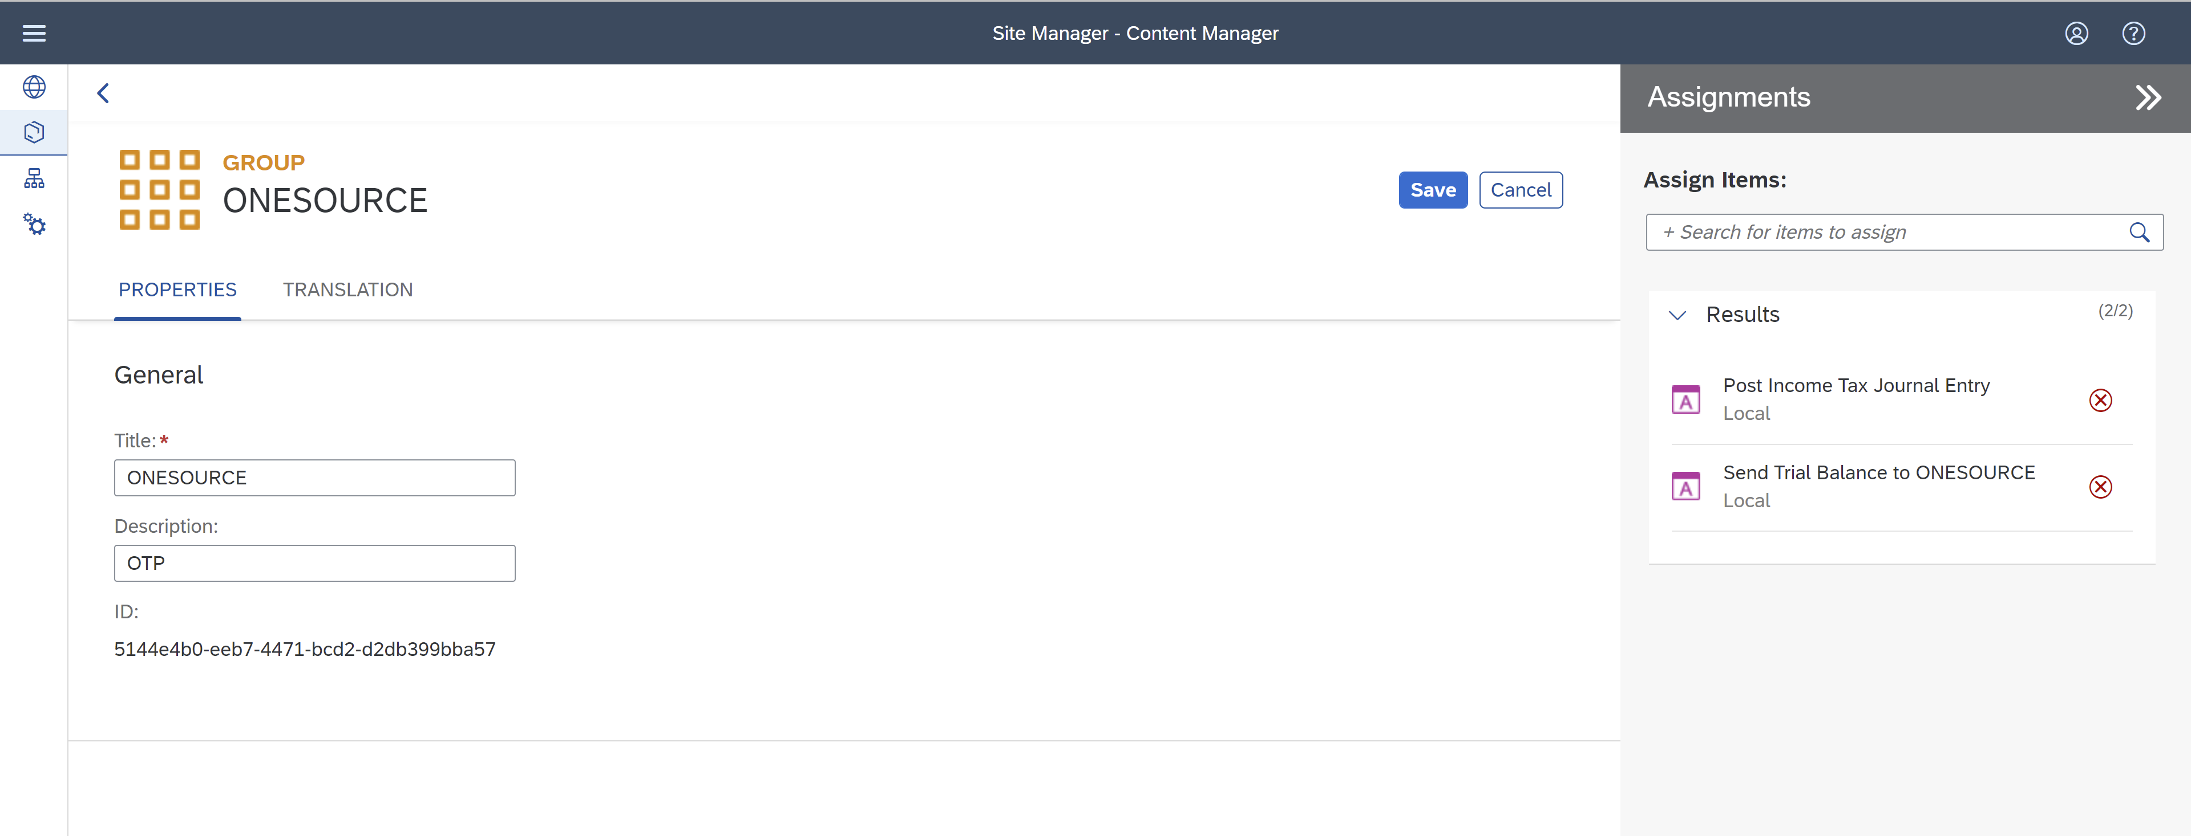

**Everyone Role Assignment for apps:**

* Click on **Everyone** role on Table.

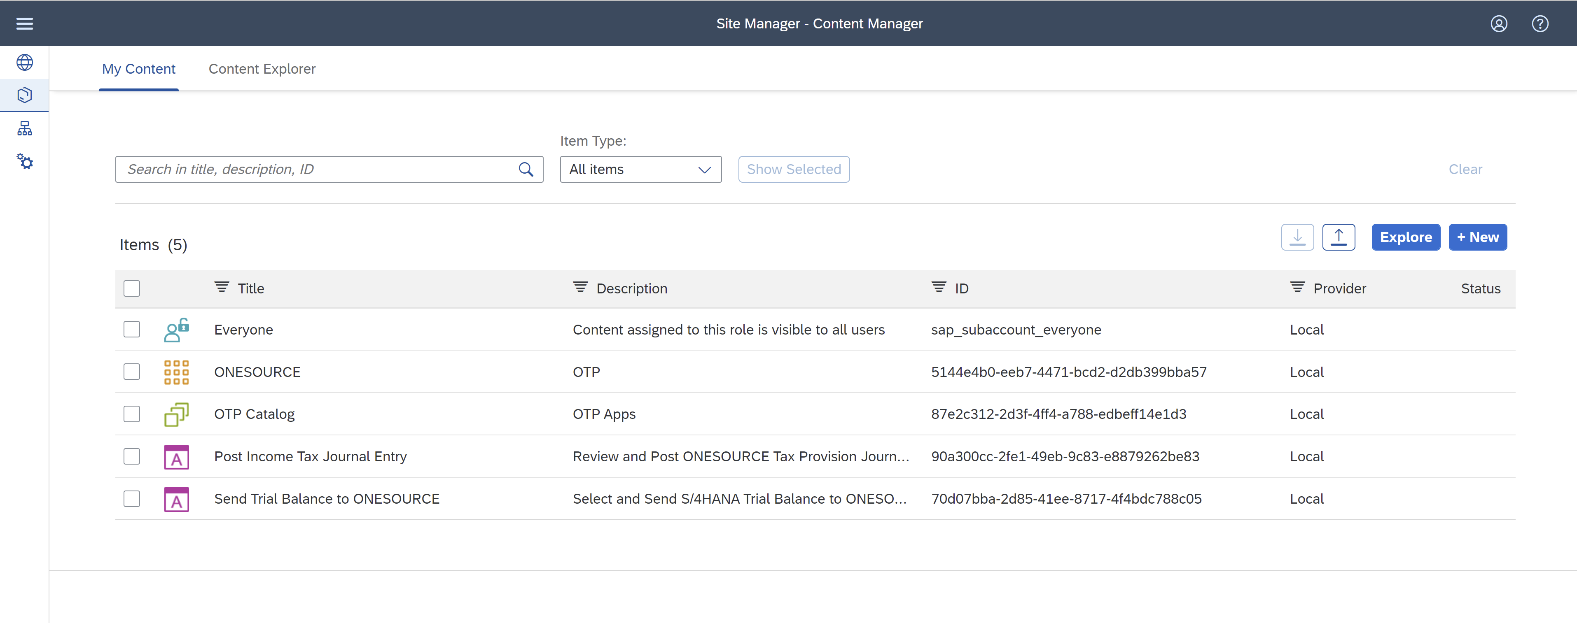

* Add Apps to the role

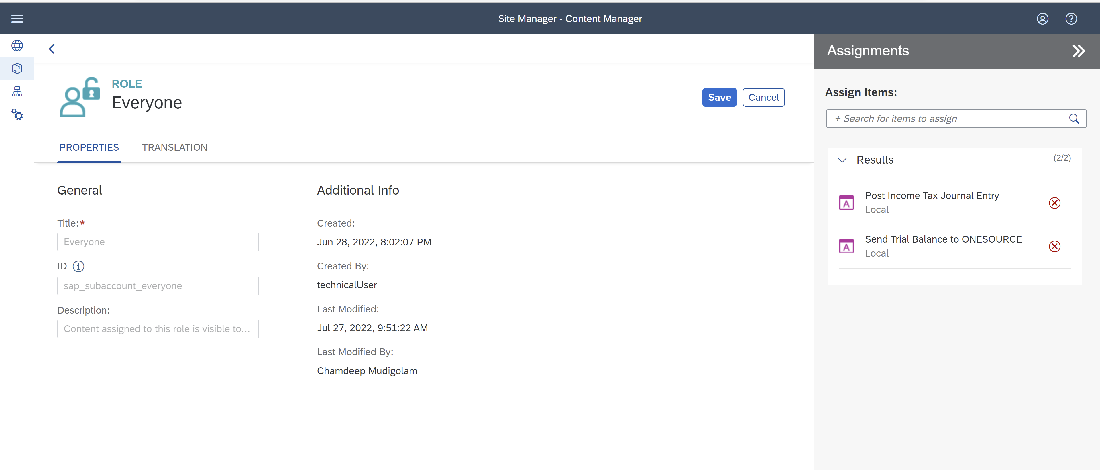

* Once everything is ready click on below button you can see the launchpad

